Module 12 – Location Graph

Exploratory Data Analysis

*In this section, you should perform some data analysis on the data provided to you. Please format your findings in a visually pleasing way and please be sure to include these cuts:*

* *Make a visual graph of your data on a map (coordinates should be within US borders)*
  + <https://mymaps.google.com/>
  + Find a map with latitude/longitude and place them approximately
  + Any alternative that gives the same effect
* A map of the united states

  AI-generated content may be incorrect.
* Use your available data to determine a good starting coordinate for the DC
  + Should you use the average of the ranges of lat longs of the stores?
    - Yes, taking the average of all store coordinates is a great first approximation of the optimal central location
  + Should you use the coordinates of the store furthest away from the current DC?
    - Nom the furthest store might minimize distance for that one store but will increase average distance for others
  + Can you think of something better to use?
    - Yes, a better method would be to use a distance-based model
    - Using either the sum of distances or weighted average
  + Whatever you use, please record the optimal function with your starting coordinate to compare to your optimized model

Model Formulation

*Try to write the formulation of the model into here prior to implementing it in your Excel model. Be explicit with the definition of the decision variables, objective function, and constraints. Hint: Linking constraints aren’t needed since we are using Nonlinear GRG but refer to the associated PowerPoint in your data if you need help.*

Constraints: 23<= x <= 50

-125 <= y <= -65

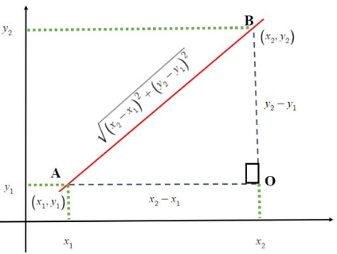

Model Optimized for Distance Reduction from DC to Store

*Implement your formulation into Excel and be sure to make it neat. This section should include:*

* *A screenshot of your optimized final model (formatted nicely, of course)*
* *A text explanation of what your model is recommending*
* *Update your graph from the EDA section by adding in your new DC and add indicators of which Stores are serviced by which DC*
* A white grid with many small numbers

  AI-generated content may be incorrect.
* My model is recommending to put a new DC center at the location: lat:38.07, long: -101.454. this location was chosen by minimizing the total distance each store mist travel to the closer of either current DC or new DC. This would overall decrease delivery distances, minimizing operational ravel cost effectively.

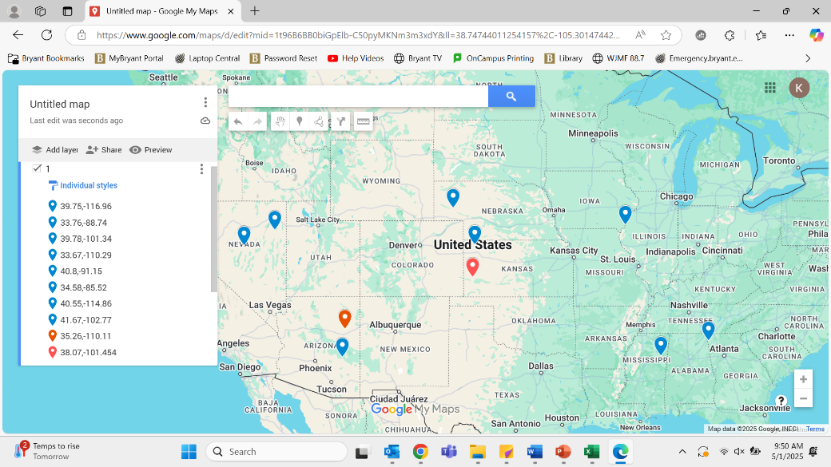

Model with Stipulation

*Please copy the tab of your original model before continuing with the next part to avoid messing up your original solution.*

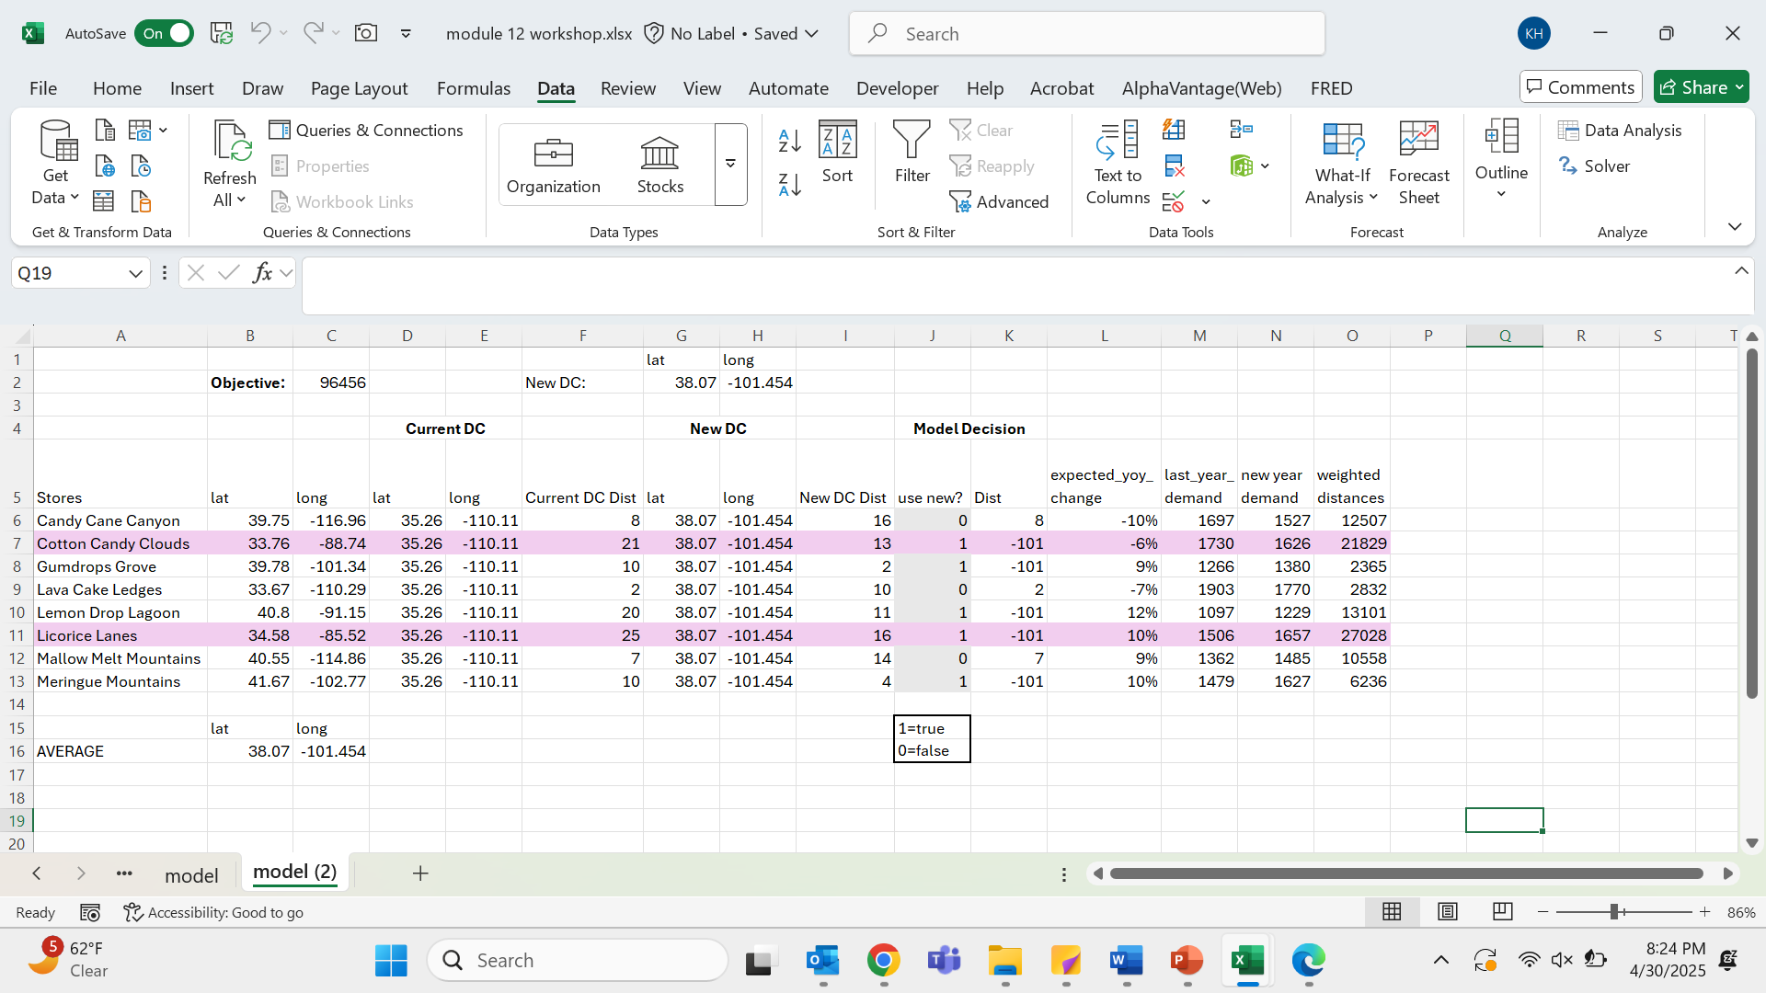

*You should notice that while distance is minimized between each store and each DC, there is a discrepancy between how much demand is serviced between each DC (i.e. one DC may service a lot more demand than others). Please:*

1. *Choose one:*
   1. *Implement a change that picks a location for the new DC to distance AND load. You can do this by multiplying distance by demand if a store is serviced by a particular DC.*
   2. *Instead of just summing the distance, also add the difference between demand serviced between each DC (i.e. if the old DC serves stores with 8000 total demand and the new DC does 3000 then the difference would be 5000). Be sure to not remove the sum of distance too, it should be both. You may want to add weights and such but not necessary*
2. *Provide a text explanation on what your model is recommending now with this change.*
   1. This model recommends: Assigning stores to the DC (current or new) that minimizes distance × demand. High-demand stores like Licorice Lanes and Cotton Candy Clouds are more influential in the objective. For example, Licorice Lanes is assigned to the new DC, even though it’s farther, because its large demand amplifies the weighted distance benefit. This improves cost-efficiency in logistics by serving high-demand stores from closer DCs, even if it means assigning low-demand stores to a slightly farther one. By adding most stores to the new DC there will be a shorter distance and better demand projections.
3. *Explain the changes to your Solver/Model.*
   1. By adding the weighted distances, the objective function used that rather than just simply the distances. Along with adding the YoY for forecasted demand. And implementing this in the model.